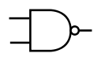
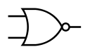
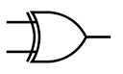
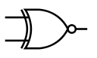
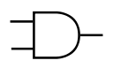
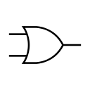
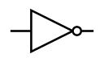
A | B | Q
0 | 0 | 1
0 | 1 | 0
1 | 0 | 0
1 | 1 | 1
A | B | Q
0 | 0 | 0
0 | 1 | 1
1 | 0 | 1
1 | 1 | 0
A | B | Q
0 | 0 | 1
0 | 1 | 1
1 | 0 | 1
1 | 1 | 0
A | B | Q
0 | 0 | 1
0 | 1 | 0
1 | 0 | 0
1 | 1 | 0
A | B | Q
0 | 0 | 0
0 | 1 | 1
1 | 0 | 1
1 | 1 | 1
A | B | Q
0 | 0 | 0
0 | 1 | 0
1 | 0 | 0
1 | 1 | 1
A | Q
0 | 1
1 | 0
NAND Gate
NOR Gate
XOR Gate
XNOR Gate
AND Gate
NOT Gate
OR Gate
Logical Gates

