RS NAND Latch
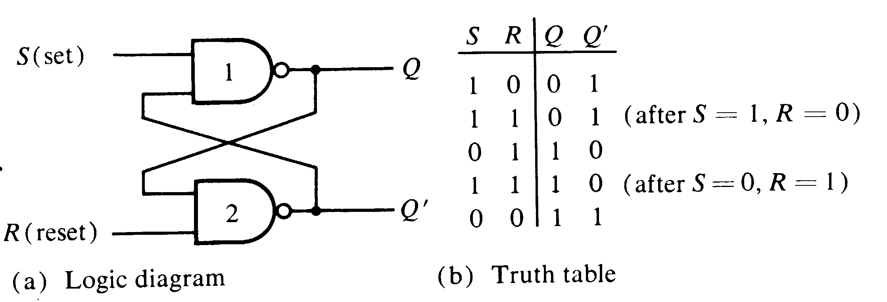

This is the RS Nand latch circuit.

Let us set P=Q’.

This stores a bit: if Q=0, the bit is off, and if Q=1, the bit is on.

Q = (S NAND P) = NOT(S AND P) = NOT(S) OR NOT(P),
P = (R NAND Q) = NOT(R AND Q) = NOT(R) OR NOT(Q).

S=0 => NOT(S)=1 => Q=1
R=0 => NOT(R)=1 => P=1

S=0 AND R=1 => Q=1 AND R=1 => NOT(P) => P=0
R=0 AND S=1 => P=1 AND S=1 => NOT(Q) => Q=0

R=1 AND S=1 => Q=NOT(P) AND P=NOT(Q)

We write the truth table as follows:

S R Q P
0 0 1 1
0 1 0 1
1 0 1 0
1 1 NOT(P) NOT(Q)

Start R, then S. Now R=1, S=1, Q=0 and P=1.
Keep R and S on.
To set Q=1, set S=0, then back to 1. (S means SET)
To set Q=0, set R=0, then back to 1. (R means RESET)

